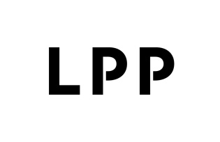

Information on the consequences of the armed conflict in Ukraine on the operations
of the LPP Group
Current report no: 06/2022
Date: 28.02.2022
Time: 10:41 a.m.

Due to the war’s outbreak in Ukraine, the Management Board of LPP SA (“Company”) with its registered office in Gdańsk informs that, as at 31 January 2022 (the end of the 2021/22 financial year), the Company had 157 brand stores in Ukraine. In the 2021/22 financial year (i.e. the period of 12 subsequent months from February 2021 to January 2022), the subsidiary LPP Ukraina generated sales of PLN 713 mln i.e. approx. 5% of the Group’s entire sales.
Following the announcement of a state of martial law in Ukraine, all stores owned by the Company were closed.
Since there is no possibility of determining any future operations on the Ukrainian market, the Company intends to write off in full all assets located in the territory of Ukraine i.e. stores (investments in foreign fixed assets), inventory and cash. The total value of the said write-off will be approx. PLN 270 mln.
Simultaneously, the Management Board informs that the Company and its employees undertake numerous actions aimed at supporting the employees of LPP Ukraina, their families and relatives as well as all other people in need of help. A special contact point has been launched for persons fleeing the endangered territory, there are transport means organised to relocate refugees from the Polish border to locations inside the country, including assistance in the form of offering care and accommodation as well as financial, psychological and legal support. In warehouses located in Ukraine, the staff distributes clothing to those in need. Aid is provided also by LPP subsidiaries operating in Slovakia, Hungary and Romania. At the same time, the LPP Foundation joined by social partners and aid organisations prepares a more comprehensive project involving material aid for Ukraine.
The Company has made no decision on withdrawing its business from Ukraine yet any operations pursued there have been suspended for an unspecified period of time until conditions ensuring staff safety are restored on the Ukrainian territory.

Article 17(1) MAR – inside information

Signatures: Przemysław Lutkiewicz – Vice-President of the Management Board
Jacek Kujawa - Vice-President of the Management Board

