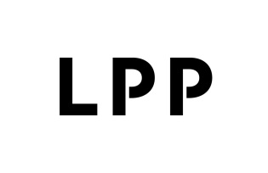

Information on transactions involving the issuer’s shares
Current report no: 22/2021
Date: 22 July 2021
Time: 15:40 pm

The Management Board of LPP SA with its registered office in Gdańsk (“Issuer”, “Company”) informs that, on 22 July 2021, it received from Semper Simul Foundation (an entity closely related to Marek Piechocki - President of Management Board, Sławomir Łoboda - Vice-President of the Management Board, Piotr Piechocki - Member of the Supervisory Board) a notification on transactions involving the Issuer’s shares.
The wording of the notification received is enclosed by the Company hereto.

Article 19(3) MAR – information on transactions executed by persons performing managerial obligations

Signatures: Przemysław Lutkiewicz – Vice-President of the Management Board
Sławomir Łoboda - Vice-President of the Management Board

